**Minefield – Task 3**

It is time to get the sprite moving! Start by adding some buttons and place some suitable images upon them (mine are plain, but yours need not be)



Then consider what should happen when a particular button is pressed? In other words, what is the algorithm, or the sequence of operations that should take place, when any given button is clicked?

Give it some thought: what actions must happen to make the sprite (appear to) move?

**The algorithm in my head before starting to code this was**

* First, I must add a function to remove the sprite image from a label at any given location. This will be quite similar to the one we already have to show a sprite at any given location. The ‘trick’ here is to set the Image property of the label to be “**null”** – which in effect removes the image from the label.
* Then, update the coordinates variables used to record the sprite’s position in the grid, in accordance with whatever button was clicked. For instance, for the up button, decrease the row coordinate by one. I made a mental note that I will also need to check that I am not already at the edge of the grid to avoid falling off it.
* Then, use the previous showSprite function to redraw the sprite on a label using the new updated coordinate location

**My Solutions:**

1. To ‘undraw’ the sprite, set the image property of the appropriate label to “null”…

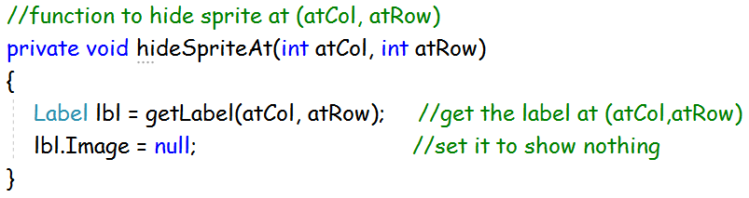

If you wish, try and code this yourself, or otherwise expand the image above to see my coding solution.

2. To move the sprite, we use the combination of hideSprite() and showSprite() functions, whilst updating the column or row coordinate variables in-between…

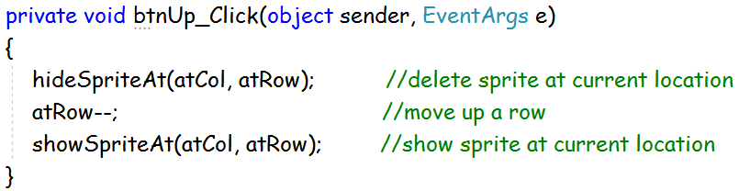

Test this works OK. Then, consider what else needs to be done?

3. Using this example, repeat and modify the coding to move the Sprite down, left, and right.

Once again, consider what else needs to be done?

4. The code still requires a bit more development. Currently, you can move the sprite off the grid, and thus cause a crash. A bit of additional coding can prevent this. Can you work it out? If not, no problem, just use mine which is hidden below – but do read it and try to understand the logic, and then apply this to all four move operations

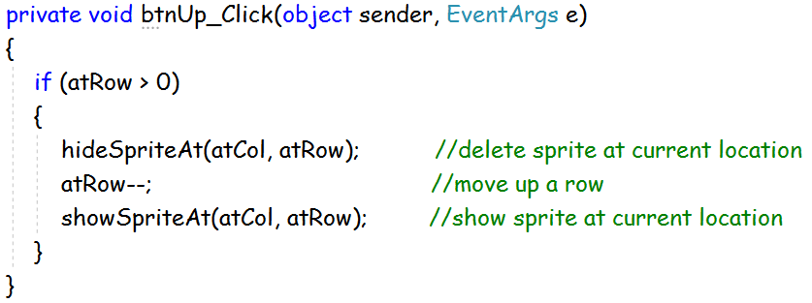

<commit3>